Parth Ray

Lab 9

1. Suppose an algorithm, KA is a 2-approximation for the 0-1 Knapsack problem. You have problem instance X and you run KA on X and get a set of items that has a value of 100. What does this tell you about the value of the optimal solution. That is:
   1. What are the range of possible values for the optimal solution?

S\* / 100 ≤ 2 100 ≤ S\* ≤ 200

* 1. Justify you answer using the definition of a 2-approximation.

Since we know that the Knapsack problem is a maximization problem, we know that the accuracy ratio must be less than or equal a c-approximation. In this case, c is equal to 2. Therefore, S\* / 100 ≤ 2, where S\* is the optimal solution. Then by multiplying 100 to both sides, we get that S\* can be at most 2 times the KA solution (S\* ≤ 200).

1. Suppose an algorithm, TA is a 2-approximation for the Assignment problem. You have problem instance X and you run TA on X and get a matching of jobs to people that has a cost of 100. What does this tell you about the value of the optimal solution. That is:
   1. What are the range of possible values for the optimal solution?

50 ≤ S\* ≤ 100

* 1. Justify you answer using the definition of a 2-approximation.

Since we know that the Assignment problem is a minimization problem, we know that the accuracy ratio must be less than or equal a c-approximation. In this case, c is equal to 2. Therefore, 100 / S\* ≤ 2, where S\* is the optimal solution. Then by solving for S\*, we get that S\* must be at least half of the TA solution (S\* ≥ 50).

1. Find an approximate solution to the TSP problem for the following graph using “Twice Around the Tree” starting from vertex a. Why might this not be a 2 approximation?

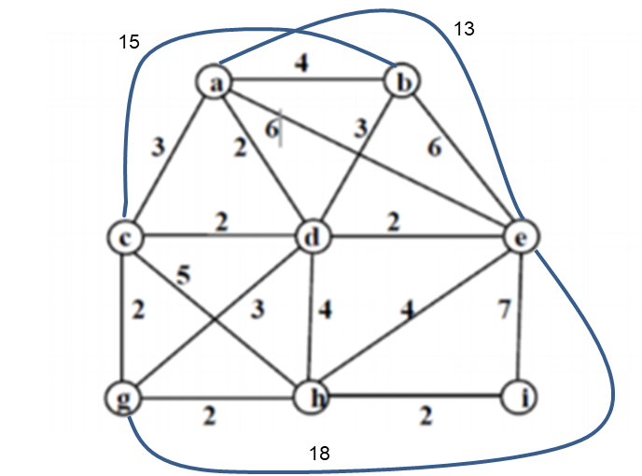

a

b

e

d

c

i

hj

g

The approximate is 39. This is not a metric TSP so it may not be a 2 approximation. The triangle inequality does not hold for this TSP. For example, the triangle formed by vertices a, d, and e has two edges that add up to 4 but this is not greater than the third edge of length 6.

1. Warm up for the oral final: Prove Twice around the tree is a 2 approximation without consulting you notes? Study it now and decide if you have any questions. Work with your group. Take turns presenting the proof. Write it out tonight.

First, we know that the value of the MST must be less than the length of the optimal tour because if the MST was greater than the length of the optimal tour, deleting one edge from the optimal tour would be smaller than the MST. And this cannot happen since we found the MST. We know the length of the path created by the twice around algorithm is 2 times the length of the MST, since it goes twice around. By definition of the algorithm, since we take a shortcut from the triangle equality as we traverse the path, the twice around the tree path must be shorter than 2 times the length of the MST. This is because if we find an edge to a vertex that has not been visited, we take it. By definition of a metric TSP, this edge we took must be less than the sum of the other two edges. Therefore, the length of the twice around the tree path must be less than or equal to 2 times the length of the optimal tour. Thus, the twice around the tree is a 2-approximation for a metric TSP.